Build in Five
Real builds, real time. From demo to deployed.

Programme Overview for Leadership & Stakeholders

Version | 4.1 — Non-Technical Summary
Date | 1 March 2026
Status | For leadership review and wider circulation
Based on | Build in Five Project Plan v4.0
Project Lead | Martin Davies / Ben Brookes
Programme Lead | Azmain Hossain
Technical Lead | Richard Dosoo

Contents

1. Executive Summary
Build in Five is a programme that transforms how Moody’s Analytics Advisory Services demonstrates, builds, and deploys applications for clients. The core idea is simple but powerful: take what used to be a six-month integration project and reduce it to roughly five minutes.
The programme has two main goals. First, it enables our Solutions Engineers to live-build working application prototypes during client meetings, proving that our Intelligent Risk Platform (IRP) is open, flexible, and easy to integrate with. Second, it gives non-technical team members — consultants, customer success managers, and project managers — a structured, guided process to design and deploy their own tools without needing a developer.
This is not a theoretical concept. The infrastructure to make it work (called the Application Factory) is already live and proven, hosting the IRP Adoption Tracker across three environments. What we are now doing is building the guided workflow, training the team, and rolling it out in a phased approach over 16 weeks.
In short: Build in Five turns every client demo into a deployable asset, every team member into a potential app creator, and every application built into a reusable component that makes the next one easier.
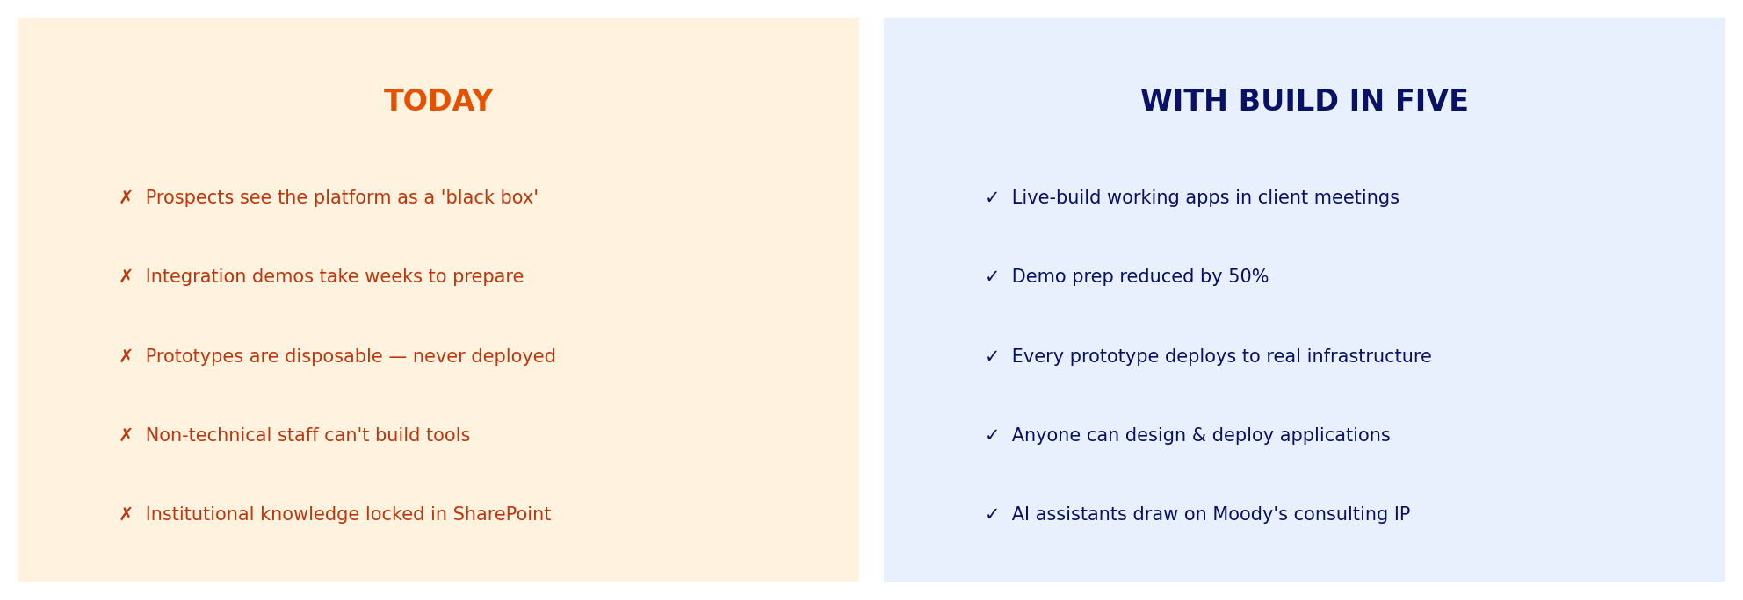
Figure 1: The shift Build in Five delivers — from disposable demos to deployed applications

2. Why This Matters

2.1 The Sales Challenge
Competitors frequently position the Moody’s platform as a “black box” — powerful analytics behind a wall that’s difficult to integrate with. When prospects raise objections like “Your platform can’t handle our data formats” or “How does this connect to our existing systems?”, the current response is often a follow-up meeting weeks later with a bespoke demo that took significant engineering time to prepare.
Build in Five changes this dynamic completely. Instead of promising to show integration later, the Solutions Engineer builds it live, in the meeting, in front of the prospect. The prototype then deploys to real infrastructure so the prospect can continue exploring it after the call. This is a fundamentally different sales experience.

2.2 The Productivity Opportunity
Beyond sales, there’s a significant internal productivity gain. Advisory Services staff regularly need small tools, dashboards, and data transformations. Currently, these require developer involvement and compete with client delivery work. Build in Five provides a structured, AI-assisted path for non-technical staff to define, build, and deploy these tools themselves.
This aligns directly with Moody’s “AI to 10x” OKR — using artificial intelligence to multiply the output and effectiveness of existing teams.

2.3 Strategic Positioning
Build in Five positions Moody’s as an AI-first engineering organisation. By using AI-assisted development with governed guardrails in front of prospects, we demonstrate that we don’t just sell analytics — we build with advanced engineering practices. This is a credibility multiplier that competitors (who demo from static slide decks) cannot match.
This mirrors the approach taken by the leading consulting firms — McKinsey, EY, Deloitte, and PwC have each built internal AI platforms for their consultants. Build in Five brings that same capability to Moody’s Advisory Services, tailored to the insurance analytics domain.

3. How It Works
Build in Five is built on three connected layers, each serving a distinct purpose. Think of it like a factory production line: the design layer defines what to build, the infrastructure layer builds and hosts it, and the knowledge layer provides institutional intelligence that makes everything smarter.
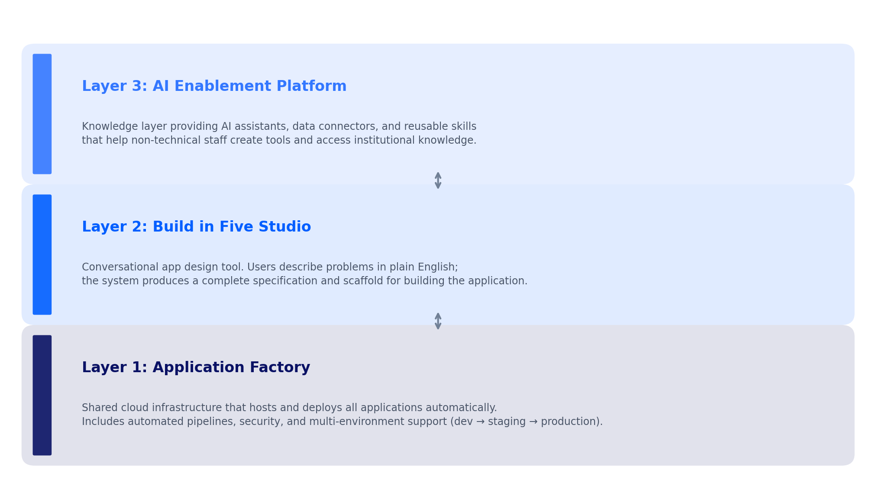
Figure 2: The three-layer architecture that powers Build in Five

3.1 Layer 1: Application Factory — The Infrastructure
The Application Factory is the shared cloud infrastructure (hosted on Amazon Web Services) that hosts all applications built through Build in Five. It is already live and proven — the IRP Adoption Tracker currently runs on this infrastructure.
What it does in simple terms: when a developer (or an AI tool) produces application code, the Application Factory takes that code and automatically deploys it to a secure, accessible web address. It handles all the behind-the-scenes complexity: security authentication (using existing Moody’s login credentials), multiple environments for testing before going live, automated quality checks, and cost management.
Key fact: Any application built locally on a developer’s machine can be deployed to the Application Factory with a single action. Five minutes from finished code to a live, accessible web application.

3.2 Layer 2: Build in Five Studio — The Design Tool
Build in Five Studio is the conversational app design tool — the “front door” of the programme. It exists in two forms: as a project within Claude (Anthropic’s AI assistant, used through the web), and as a standalone web application deployed on the Application Factory.
Users describe their problems in plain English. The Studio guides them through a structured conversation, asks clarifying questions, and ultimately produces two outputs: an App Brief (a structured specification of what needs to be built) and a Scaffold Prompt (a set of instructions that development tools can use to generate the actual application code).
The Studio also includes a complexity guard that evaluates whether the user’s request actually needs a full application, or whether a simpler solution (like a script or spreadsheet) would suffice. This prevents over-engineering and ensures resources are used wisely.
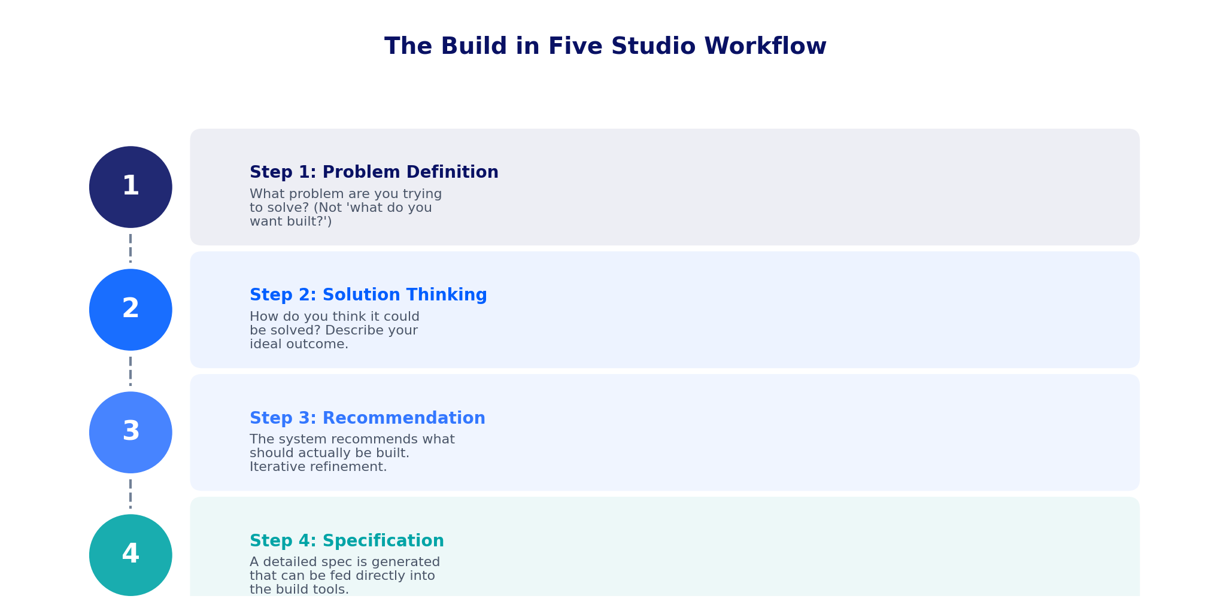
Figure 3: The four-step guided workflow inside Build in Five Studio
Design philosophy: The workflow starts with “What is the problem you’re trying to solve?” rather than “What do you want built?” This is deliberate. By forcing problem-first thinking, the process filters out trivial requests and ensures that what gets built actually solves a real need. The friction is a feature, not a bug.

3.3 Layer 3: AI Enablement Platform — The Knowledge Layer
Led by Azmain Hossain, the AI Enablement Platform is a parallel programme that provides AI-powered tools and institutional knowledge access for non-technical staff. While Build in Five focuses on sales demos and application prototyping, the AI Enablement Platform serves a broader audience: customer success managers, project managers, and analysts.
The platform provides three key capabilities. First, data connectors that let AI tools securely access Moody’s internal systems (SharePoint, Snowflake, Atlassian). Second, a library of over 30 pre-built “skills” — reusable AI capabilities like combining Excel files, generating branded documents, building dashboards, and querying databases. Third, a planning layer that helps non-technical users break down complex tasks into manageable steps.
How the two programmes connect: Build in Five and the AI Enablement Platform share infrastructure (the Application Factory) and governance frameworks, but serve different audiences and run as separate engagements. The AI Enablement Platform enriches Build in Five by providing live data access during demos and institutional knowledge for specification generation.

4. The Concept in Action: Live Demo Scenarios
Three demo scenarios have been designed to systematically dismantle the “black box” objection. Each addresses a common prospect objection and proves, through a live build, that IRP is open and extensible. Together, they tell the complete “open platform” story.
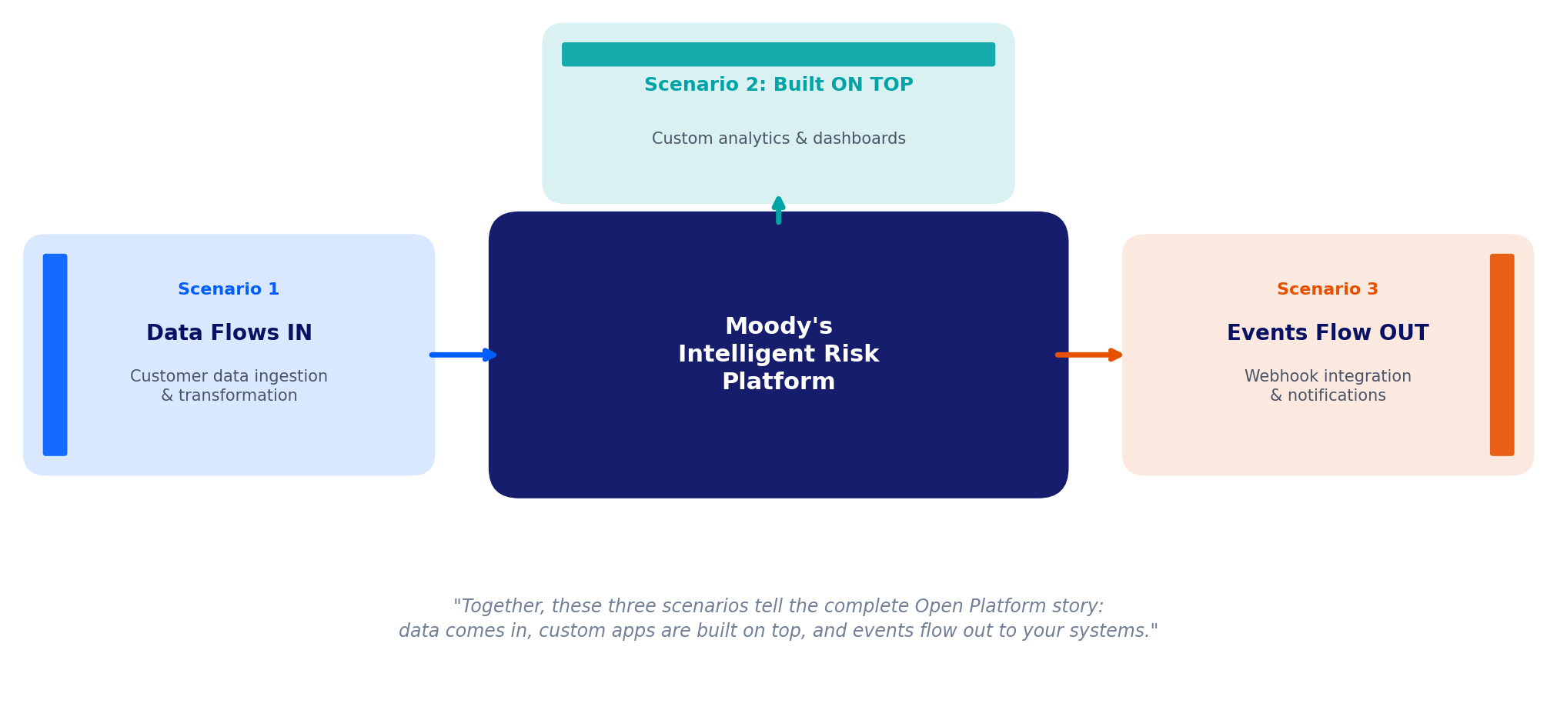
Figure 4: The three demo scenarios demonstrate the full open platform story

Scenario 1: Data Flows IN — Data Ingestion Pipeline
Objection addressed: “Your platform can’t handle our data formats.”
In this demo, the Solutions Engineer live-builds a data ingestion service that reads a sample client data file, transforms it to the required format, validates it against quality rules, and writes it into the platform’s sandbox environment. The prospect sees their own data flowing into the system in real time.
Live build time: approximately 4–5 minutes. Deployment to shared infrastructure: approximately 10 minutes post-call.

Scenario 2: Built ON TOP — Custom Analytics Interface
Objection addressed: “We need custom analytics views your out-of-the-box product doesn’t support.”
The SE builds a custom dashboard that queries platform data and renders bespoke visualisations — exposure by geography, peril, or line of business. The prospect gets a live URL they can explore independently after the call.
Live build time: approximately 3–4 minutes.

Scenario 3: Events Flow OUT — Guidewire Integration
Objection addressed: “How does this integrate with our existing underwriting workflow?”
This is the most powerful proof point. The SE builds a service that listens for underwriting decision events from the platform and automatically triggers a notification to the prospect’s downstream system (such as Guidewire’s Policy Centre). This is a real-world integration pattern that was previously estimated at six months of development time.
This scenario transforms a “six-month problem” into a “five-minute problem.” It is the single most compelling demonstration of what Build in Five enables.

5. The Compound Value Effect
One of the most strategically important aspects of Build in Five is how its value compounds over time. Every application built through the programme adds to a Solutions Database — a growing repository of previously built application specifications, components, and patterns.
The more applications that are built, the richer this database becomes. Over time, building a new application will increasingly start from selecting and combining existing components rather than starting from scratch. This is where the real intellectual property value accumulates.
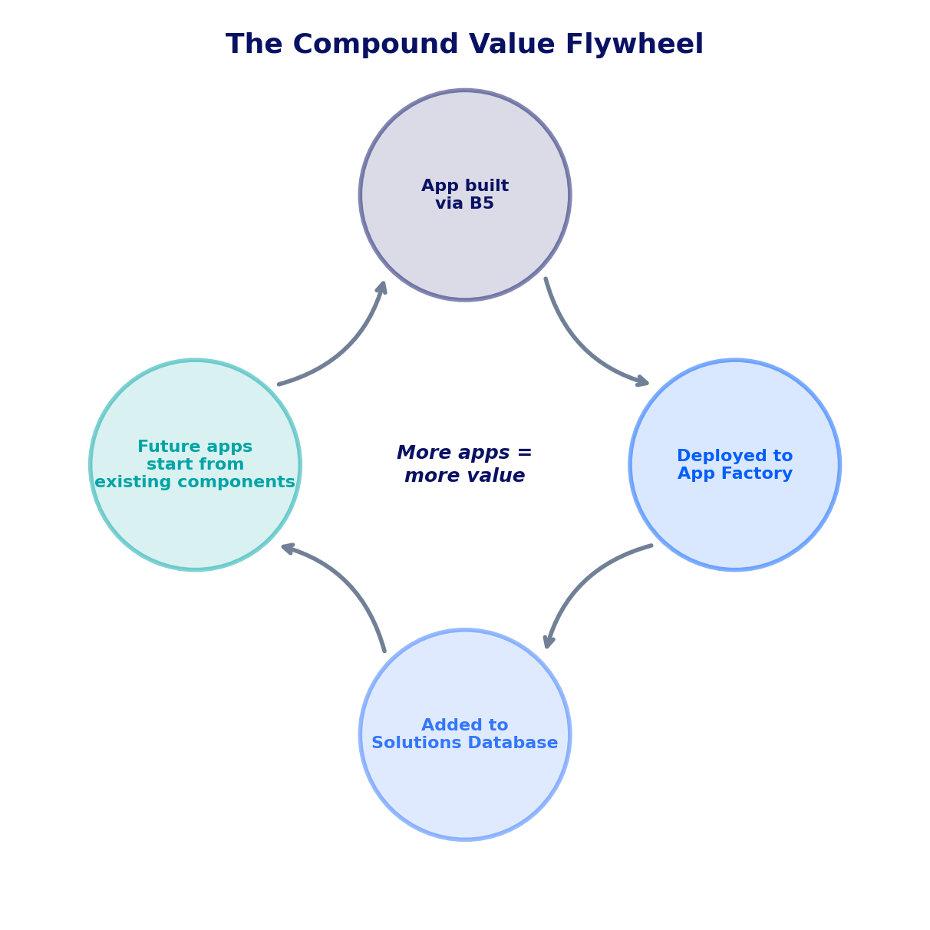
Figure 5: The compound value flywheel — each application built makes the next one easier
The long-term vision includes a Solutions Database with a “shopping cart” experience: users browse pre-built features, select what they need, and the system generates a composite specification that combines them. This means that an application which might have taken five minutes to build from scratch could eventually take thirty seconds to assemble from existing parts.

6. Consulting IP Strategy
Advisory Services holds significant intellectual property in presentations, pitch decks, methodologies, engagement playbooks, and client deliverable templates stored in SharePoint. Currently, this knowledge is difficult to find and reuse. The consulting IP strategy aims to make this institutional knowledge accessible to AI tools so they can create content grounded in how Moody’s actually delivers consulting engagements.

6.1 The Approach
The strategy uses a three-system architecture to organise and govern consulting knowledge:
System | Tool | What It Does
System of Record | SharePoint | Where all consulting assets live. The single source of truth.
Master Data Management | Semarchy | Governs how data entities relate to each other and ensures quality across systems.
Governance & Classification | Microsoft Purview | Classifies documents by sensitivity, tracks data lineage, and applies security labels.

AI tools will access this knowledge in two ways: through direct, real-time access to SharePoint documents for on-demand retrieval, and through a semantic search capability for broader questions like “What methodology do we use for adoption assessments?” Over time, the system also captures lessons learned from consulting engagements, building an evolving playbook that improves with every project.

7. Measuring Success
Success is measured across four primary metrics, each designed to demonstrate tangible business impact:
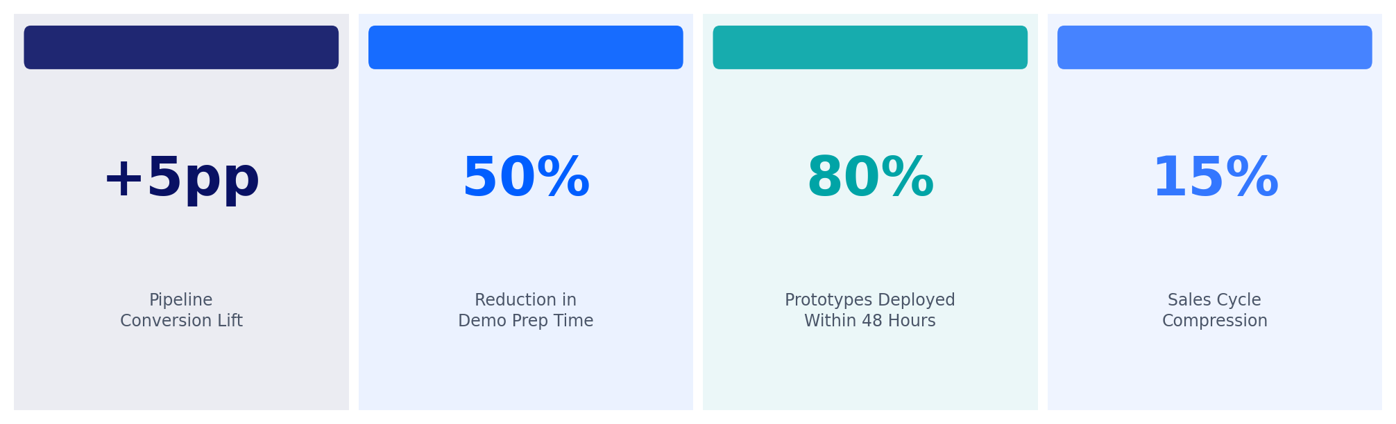
Figure 6: The four primary success metrics for Build in Five

7.1 Detailed Metric Definitions
Metric | What We Measure | Target | How
Pipeline conversion lift | Win rate for deals using Build in Five demos compared to standard demos | +5 percentage points | CRM deal tagging and pre/post comparison
Demo velocity | Time to prepare a custom demo for a prospect | 50% reduction | Tracked per demo event
Prototype-to-deployment rate | Percentage of demo prototypes deployed to the Application Factory within 48 hours of the demo | 80% by Phase 2 | Factory deployment logs
Sales cycle compression | Average days from first demo to deal close for tagged vs untagged deals | 15% reduction | CRM analytics over 6-month rolling window

7.2 Additional Tracking
Beyond the primary metrics, the programme will also track Application Factory utilisation (number of active apps, cost per app, monthly trend), AI Enablement Platform adoption (active users, tasks completed, popular skills), and qualitative feedback from both Solutions Engineers and prospects.
Measurement approach: A baseline report will be completed before Phase 1 begins, establishing current win rates and demo preparation times. CRM opportunities will be tagged with “Build in Five” for live demos and “App Factory deployed” for deployed prototypes. Conversion and cycle data will be compared for tagged vs non-tagged deals over a rolling six-month window.

8. Delivery Timeline
The programme is structured as a 16-week phased rollout, compressed from the original 25-week plan because the Application Factory infrastructure is already live and proven. Each phase has clear entry and exit criteria to ensure the programme progresses only when it is ready.
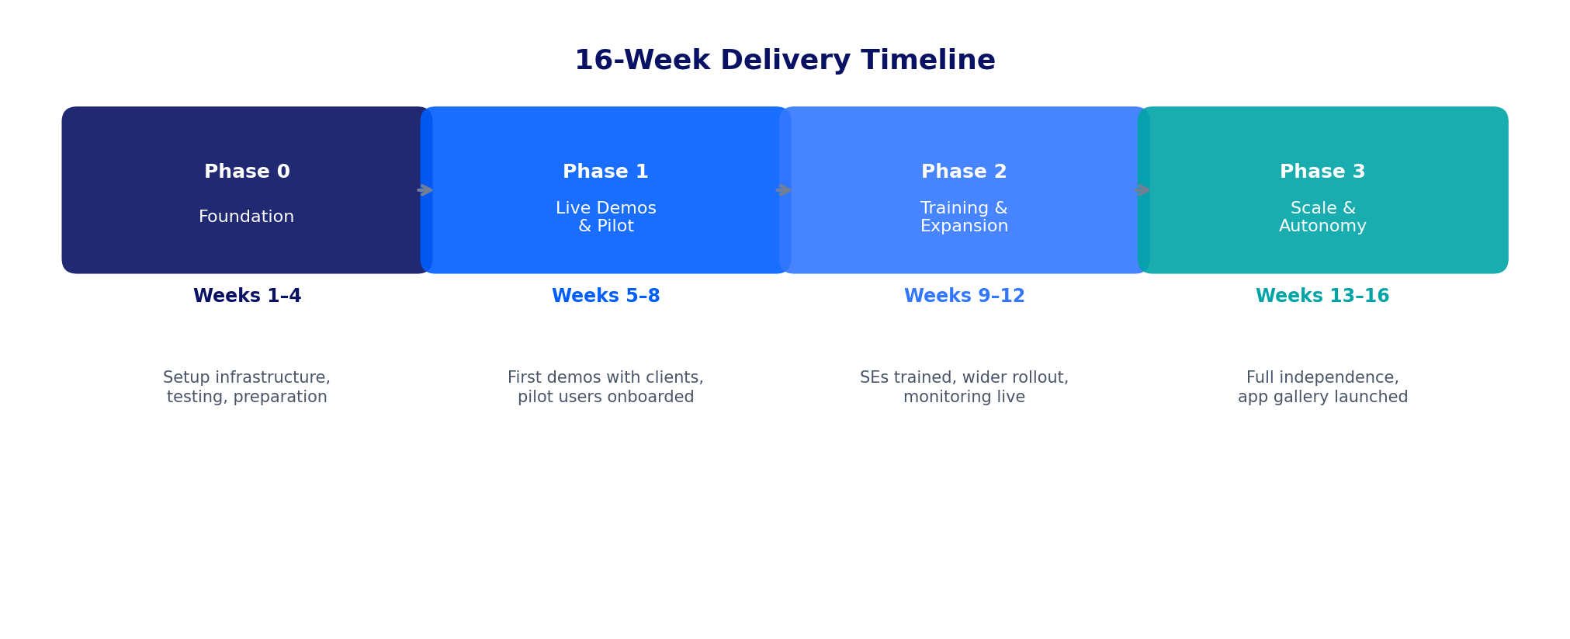
Figure 7: The four-phase delivery timeline

8.1 Phase 0: Foundation (Weeks 1–4)
Setting up the building blocks. This includes finalising infrastructure modules, testing and verifying all scaffold prompts (the instructions that generate application code), validating sandbox datasets, confirming all licensing, and productising the Build in Five Studio as a usable tool. The AI Enablement Platform begins its Bedrock setup and deploys initial data connectors in parallel.
Team commitment: 12–18 hours per week across the core team.

8.2 Phase 1: Live Demos & Pilot (Weeks 5–8)
The first live client demos begin, running at a pace of 3–4 per week. Advisory Services leads (or co-leads) every demo with a maximum of two pilot Solutions Engineers. First prototypes are deployed to the Application Factory. The AI Enablement Platform onboards 10–20 pilot users and makes live data connectors available for demo scenarios.
Exit criteria: Minimum 8–10 demos completed, at least 6 prototypes deployed, CRM tagging in use, costs within budget, and a formal decision to proceed to Phase 2.

8.3 Phase 2: Training & Expansion (Weeks 9–12)
Solutions Engineers begin running demos with Advisory Services on standby rather than leading. SEs learn to deploy to the Application Factory independently. The AI Enablement Platform expands to 50–100 users and introduces self-service skill creation. A monitoring dashboard goes live to track usage and costs.
Exit criteria: SE-led demos completed independently, prototype-to-deployment rate at 60% or above, Advisory Services involvement reduced to 4 hours per week or less.

8.4 Phase 3: Scale & Autonomy (Weeks 13–16)
Solutions Engineers operate fully independently. An app gallery and community of practice are launched. The consulting IP profiling strategy becomes active, with AI tools drawing on Moody’s institutional knowledge. Cross-team skill sharing begins, and the programme transitions to steady-state operations.
Exit criteria: 80%+ of demos SE-led, prototype-to-deployment rate at 80%+, conversion lift and factory metrics reported per measurement specification.

9. The Team
A dedicated team has been proposed to drive the combined Build in Five and AI Enablement Platform programmes. This proposal has been submitted for leadership approval.
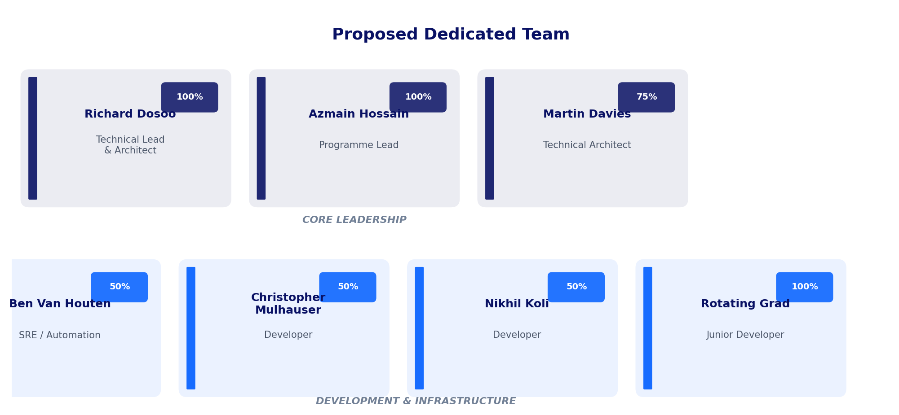
Figure 8: The proposed dedicated team and their allocation to the programme
Person | Role | Allocation | Primary Focus
Richard Dosoo | Technical Lead & Architect | 100% | Application Factory, Build in Five Studio, .cursorrules, consulting IP, architecture
Azmain Hossain | Programme Lead | 100% | AI Enablement Platform design and delivery, skills library, MCP architecture, programme management
Martin Davies | Technical Architect | 75% | Demo scenarios, scaffold prompts, SE enablement, GSD templates
Ben Van Houten | SRE / Automation | 50% | CI/CD pipeline, infrastructure, monitoring, Terraform modules
Christopher Mulhauser | Developer | 50% | Application development, skill implementation
Nikhil Koli | Developer | 50% | Application development, IRP Navigator support
Rotating Grad (TBD) | Junior Developer | 100% | Implementation tasks, testing, documentation

9.1 Advisory Services Commitment by Phase
The team’s time commitment reduces as the programme matures and Solutions Engineers gain independence. Phase 0 requires the highest effort (12–18 hours per week), Phase 1 drops to 8–10 hours per week, Phase 2 to 4–6 hours, and Phase 3 to just 2–4 hours per week for complex or high-stakes situations only.

10. Investment & Costs
The programme’s infrastructure costs are modest relative to the expected business impact. The primary cost drivers are cloud hosting (AWS), AI platform access (Amazon Bedrock), and development tooling (Cursor licences).
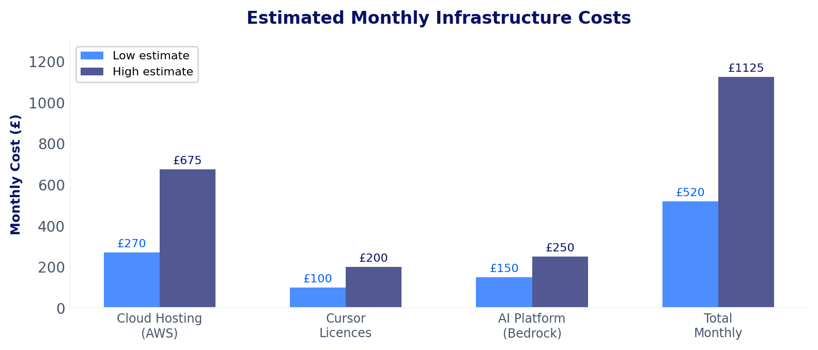
Figure 9: Estimated monthly infrastructure costs (low and high estimates)
Cost management: A monthly cap of £750 has been proposed for the Application Factory, with automatic alerting at 80% (£600). Applications that are inactive for 30 days are flagged for decommissioning. A scale-to-zero policy ensures that unused applications do not incur ongoing compute costs.
People costs: The primary investment is in the dedicated team outlined in Section 9. Martin Davies’s budget has been approved at 75% allocation for 12 weeks. The full dedicated team proposal is pending leadership approval. Beyond the initial 12 weeks, continued resource allocation will depend on Phase 1 results and formal budget extension.

11. Risk Management
The programme carries risks that are understood and have specific mitigations in place. The most significant risks relate to the live demo experience and team capacity.
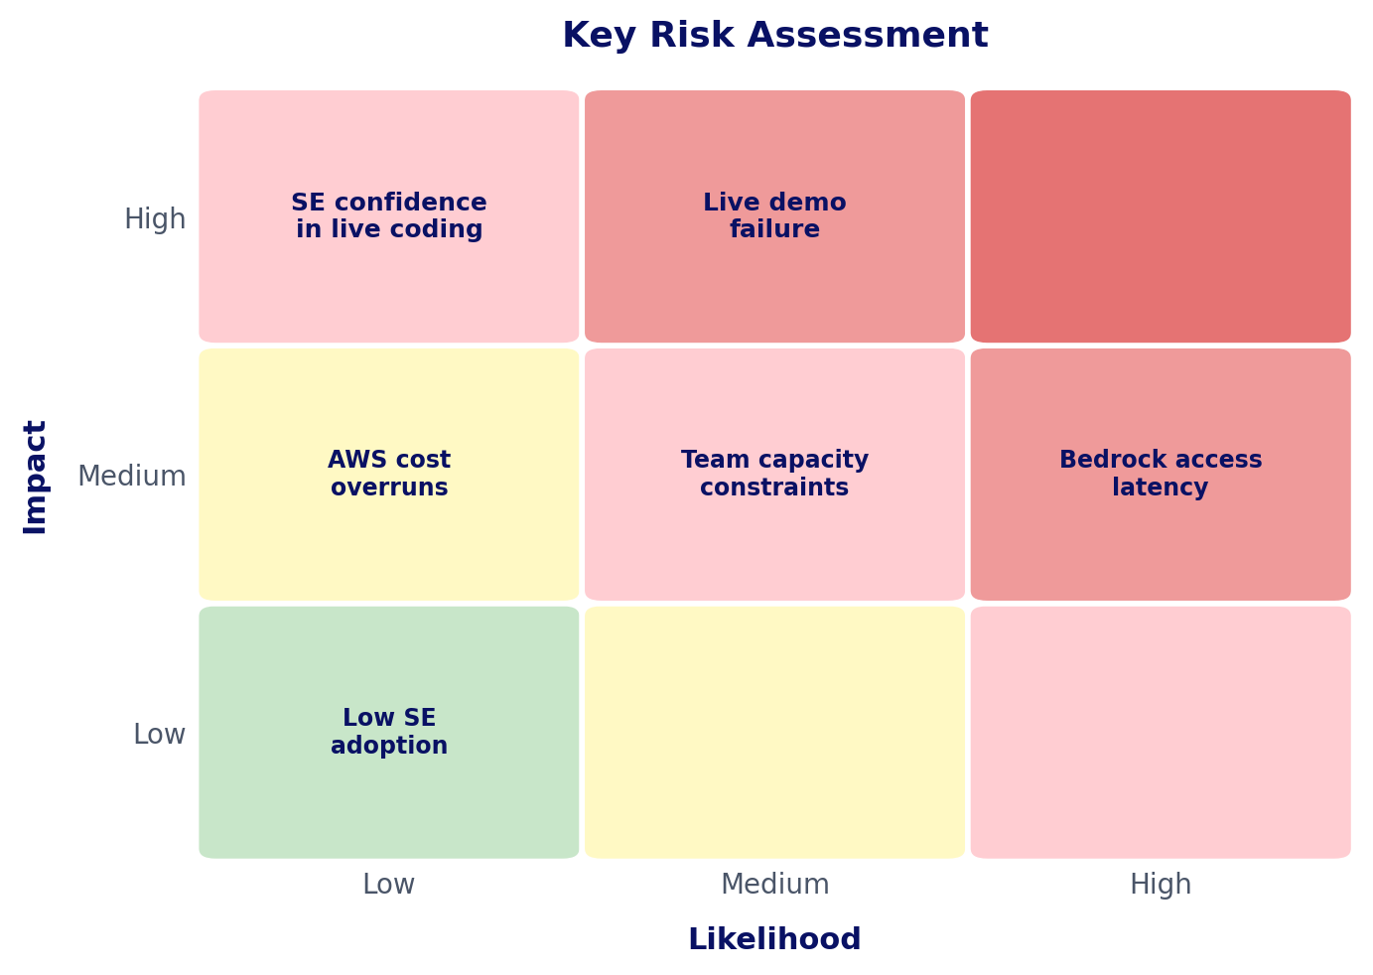
Figure 10: Risk assessment matrix showing key programme risks by likelihood and impact

11.1 Key Risks and Mitigations
Risk | Likelihood | Impact | Mitigation
SE confidence in live coding | High | High | Phased rollout with AS shadowing every demo. Pre-built templates. Practice sessions before first live demo. Automated guardrails enforce correct patterns.
Live demo failure (code errors or environment issues) | Medium | High | Dedicated failure handling playbook. Every demo template includes a pre-built fallback branch. Two-strike rule: if two errors occur, pivot immediately to the completed version.
Advisory Services capacity constraints | Medium | Medium | Dedicated team proposed. Phase 1 capped at 2 pilot SEs. Capacity reviewed at each phase gate.
Application Factory cost overrun | Medium | Medium | Scale-to-zero policy. 30-day inactivity flag. Budget alert at 80%. Monthly cost review.
AI platform access or latency issues | Medium | Medium | Authentication confirmed working. VPN-only access. Fallback to direct Cursor if needed.
Low SE adoption (defaulting to standard demos) | Low | Medium | Executive sponsorship. Win stories published. Conversion data made visible in CRM.

11.2 Live Demo Failure Handling
Live coding inherently carries risk. The programme addresses this with three principles:
- Never apologise for the tool. Frame any hiccup as iterative development: “This is exactly what happens in real integration work — let me show you how quickly we resolve it.”
- Every demo template includes a pre-built fallback branch. If the live build encounters issues, the SE pivots to the finished version seamlessly.
- Two-strike rule: if the live build encounters two errors, the SE pivots immediately to the pre-built fallback. No persistence beyond two attempts.

12. Who Benefits
Beneficiary | What They Get
Sales Team | Higher win rates, shorter sales cycles, differentiation via live deployable demos. Follow-up calls reference a running application rather than a slide deck.
Prospective Clients | Direct proof of technical feasibility. Access to a deployed prototype they can explore. Reduced risk perception around integration complexity.
Advisory Services | Increased pipeline visibility, reusable templates, demonstrable AI-first capability. Non-technical staff gain ability to self-serve through the AI Enablement Platform.
Engineering / Product | Real-time market feedback on integration pain points. A growing library of deployed integration patterns.
Platform / DevOps | The Application Factory becomes a reusable internal capability that extends well beyond sales demos.
CSMs / PMs / Analysts | AI Enablement Platform enables tool creation without developer dependency. Consulting IP accessible through natural language.

13. Decisions Required
The following decisions require leadership input to proceed:
Decision | Recommendation | Owner
Dedicated team approval | Start lean with Richard + Azmain, expand based on Phase 1 results. Full team approval deferred until measurable outcomes are demonstrated. | Diya Sawhny
Cloud infrastructure approach | Shared cluster with separate namespaces (cost-efficient at 10–15 apps plus 20 sandbox users). | Platform / DevOps
AI Platform pilot scope | Prioritise 3–4 core skills for pilot: Excel combiner, dashboard builder, Snowflake query helper, and branded document generator. | Azmain
When to enable live data in demos | Week 5 (when data connectors are ready). Live data makes demos dramatically more compelling. | Richard + Azmain
Consulting IP approach | Hybrid: direct access for specific document retrieval, semantic search for broad questions. | Richard + Jordan
AWS budget threshold | Set monthly cap at £750 with automated alerting at 80% (£600). | Project Lead + Finance

14. Next Steps
The following actions are required to move the programme forward:
- Leadership review and approval of this plan, including the dedicated team proposal.
- Confirm sandbox dataset owner — this is the highest-risk open dependency.
- Submit security authentication (Entra ID) app registration requests for new factory applications. This has the longest lead time of any dependency.
- Confirm cloud cluster capacity for 10–15 additional services with Platform/DevOps.
- Select pilot Solutions Engineers for Phase 1 (maximum 2).
- Schedule Semarchy architecture meeting with Jordan Callisher and the TSG Product team.
- Agree AWS budget threshold and configure cost alerting at 80%.
- Schedule Advisory Services capacity for Phase 0 (Weeks 1–4).
- Martin Davies to review and confirm v4.0 additions upon return.

For questions or to discuss any aspect of this programme, please contact Richard Dosoo (Technical Lead), Azmain Hossain (Programme Lead), or Martin Davies (Technical Architect).

Appendix A: Technical Architecture Details
This appendix provides the technical detail behind the Application Factory infrastructure. It is included for reference and is not required reading for the main body of this document.

A.1 Application Factory Components
Component | Configuration | Notes
ECS Cluster | Fargate, 3 environments | Branch-driven: develop→dev, staging→staging, main→prod
ECS Services | 1–2 per app (frontend + backend) | Fargate launch type with auto-scaling available
Load Balancer (ALB) | Shared with path-based routing | HTTPS termination. Each app gets its own target group.
Container Registry | Separate repos per app | Immutable images dual-tagged: sha-{commit} + {env}-latest
Database (RDS) | PostgreSQL 15, shared instance | Per-app databases. Accessed via SSM bastion tunnel.
Secrets Manager | Per app per environment | Pattern: /factory/{app-name}/{env}/secret-name
DNS (Route 53) | Subdomain per app per env | dev.advisory-appfactory.com (confirmed live)
Authentication | Microsoft Entra ID SSO/OIDC | MSAL React frontend, JWT validation backend
CI/CD | GitHub Actions per repo | OIDC federation to AWS. PR guardrails: migration validation, tests, builds.
AI Agent Workflows | Label-driven GitHub Actions | user-feedback → Claude analysis, ai-execute → implementation, ai-approve → PR creation

A.2 AWS Cost Model per Application
AWS Service | Per-App Resource | Estimated Cost
Load Balancer (ALB) | Shared ALB, per-app target group | £20–25/mo (shared)
ECS Compute | 1–2 services (Fargate) | Variable (compute-based)
Container Registry | 1–2 repos per app | £0.10/GB/mo
Database (RDS) | 1 database on shared instance | Negligible marginal cost
Secrets Manager | 2–5 secrets per app | £0.40/secret/mo
DNS (Route 53) | 1 A/ALIAS record | <£1/mo

Total estimated steady-state cost: £270–£675 per month for the Application Factory hosting. Proposed budget cap: £750/month with 80% alerting.

Appendix B: Mandatory Tech Stack
Every application built through Build in Five must use this standardised technology stack. This ensures consistency, security, and compatibility with the Application Factory deployment pipeline. A rules file (.cursorrules) enforces these requirements automatically in the development environment.
Layer | Technology | Purpose
Backend | FastAPI + Uvicorn | Web application framework (Python)
Backend | SQLAlchemy 2.x + Alembic | Database access and migration management
Backend | PostgreSQL 15+ | Relational database
Backend | Microsoft Entra ID | Authentication and role-based access control
Frontend | React 18.x + Vite | User interface framework and build tool
Frontend | Tailwind CSS 3.x | Styling (utility classes only)
Frontend | MSAL React | Single sign-on with Moody’s credentials
Infrastructure | Docker multi-stage builds | Containerised deployment
Infrastructure | GitHub Actions CI/CD | Automated testing and deployment
Infrastructure | Terraform | Infrastructure as code

B.1 Key Conventions
- All API endpoints authenticated by default with role-based access control
- Soft deletes only (data is never permanently removed)
- All secrets stored as environment variables (never in source code)
- Moody’s brand colours enforced: navy #1a2942, teal #00a4a6, light grey #f0f4f8
- Full audit trail on all records (who created it, when, and every change)

Appendix C: Detailed Deliverables Tracker
The programme has 30 identified deliverables. Key deliverables are summarised below. For the full tracker with owners, dependencies, and phase gates, refer to the technical v4.0 document.
ID | Deliverable | Target | Status | Owner
D2 | Licensing and access memo (Cursor + Bedrock) | W1–W2 | Done | IT / Procurement
D3 | Sandbox dataset specification | W1–W2 | In Progress | Engineering
D6 | Build in Five scaffold prompts (3 scenarios) | W3–W4 | Done | Advisory / Pre-Sales
D10 | Baseline report (current win rates, prep times) | W4–W12 | Planned | Sales Ops
D19 | Application Factory Terraform modules | W3–W5 | Done | Richard
D23 | Application Factory architecture deck | W2 | Done | Richard
D24 | .cursorrules v2 (tech stack enforcement) | W3 | Done | Richard
D25 | Build in Five Studio (Claude Project) | W3 | Done | Richard
D26 | AI Enablement Platform specification | W4 | Done | Azmain
D27 | Consulting IP profiling workbook | W12–W14 | In Progress | Richard
D30 | Dedicated team proposal and resource plan | W4 | Done | Richard

Appendix D: Cross-Programme Dependencies
Build in Five and the AI Enablement Platform are separate programmes with eight identified dependencies that require coordination.
Dependency | From | To | Risk | Resolution
Bedrock IAM roles | AI Platform | Build in Five | Medium | OIDC federation config shared W1–W2
Shared ECS cluster | App Factory | AI Platform | Low | Separate namespaces; cost-efficient at current scale
MCP Tier 1 for demo data | AI Platform | Build in Five | Medium | MCP servers available W5; enables live data in demos
App Factory Terraform for Level 5 apps | App Factory | AI Platform | Low | Modules documented W12; AI Platform users deploy full web apps
Entra ID app registrations | IT / Security | Both | High | Longest lead time; submit requests W1
Semarchy MDM access | TSG Product | Consulting IP | Medium | Meeting to be scheduled; architecture agreed
Consulting IP SharePoint structure | Advisory | AI Platform | Low | Profiling workbook in progress
AI agent GitHub Actions | App Factory | CI/CD | Low | Label-driven workflows already live

Appendix E: Glossary of Terms
Key terms used throughout this document, explained for a non-technical audience.
Term | Definition
Build in Five (B5) | The programme and process for rapidly prototyping IRP applications. The name reflects the aspiration to go from idea to deployed prototype in roughly five minutes.
B5 Studio | The conversational design tool where users describe problems in plain English and receive a structured application specification.
Application Factory | The shared cloud infrastructure (on AWS) that automatically hosts and deploys all applications built through Build in Five.
App Brief | A structured specification (in JSON format) that describes what an application needs to do, generated by the Build in Five Studio.
Scaffold Prompt | A set of instructions generated by the Studio that development tools use to generate the actual application code.
IRP | Intelligent Risk Platform — Moody’s core insurance analytics platform that Build in Five demonstrates and builds on top of.
MCP Server | Model Context Protocol server — a secure connection that lets AI tools access data from internal systems like SharePoint and Snowflake.
Cursor | An AI-assisted code editor used for rapid application development. Think of it as a code editor with a built-in AI assistant.
Claude Code | Anthropic’s command-line AI tool for coding tasks. More powerful than standard Claude for project-level work.
.cursorrules | A configuration file that automatically enforces the correct technology patterns and security rules when developers write code in Cursor.
Entra ID | Microsoft’s identity and access management service (formerly Azure AD). Used for single sign-on with Moody’s credentials.
CI/CD | Continuous Integration / Continuous Deployment — automated pipelines that test and deploy code changes.
ECS Fargate | Amazon’s serverless container service. Runs applications without managing physical servers.
Terraform | A tool for defining and managing cloud infrastructure through code rather than manual configuration.
Solutions Database | A planned repository of all previously built applications and their specifications, enabling component reuse.
Exceedance | Moody’s annual client event. The innovation panel slot is a key opportunity to demonstrate Build in Five.

End of Document

